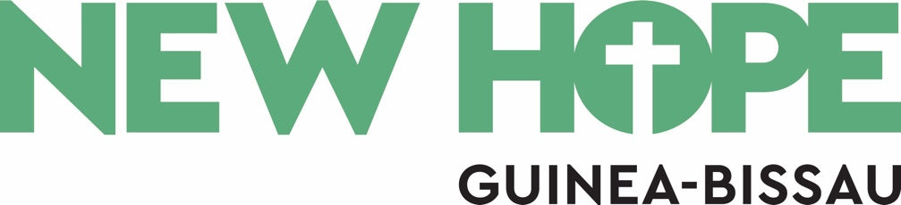

Notice about Gift Aid

We are currently awaiting confirmation of our charity number from the Charity Commission and are therefore unable to claim gift aid on donations at this time.

once we are able to do so, we will share an update on all our social media platforms.

Thank-you for your understanding.

